Contents
Slide 2: Project Overview & Context of Use 3
Slide 3: Problem Statement & Objectives 4
Phase II: Business Process Modeling 5
Phase III: Logical Database Design 6
Phase IV & V: Database Creation & Table Implementation 7
Phase VI: Advanced PL/SQL Implementation 8
Figure: Implementation of PL/SQL Procedures, Functions, and Packages. 9
Phase VII: Advanced Database Features (Triggers & Audit System) 10
Conclusion 11

Laundry Management System
Capstone Project: Final Examination
Course: DPR400210 – Database Programming

Student Name: Ahmed Zaki Ahmed
Student ID: 31195/2025
Academic Year: 2025-2026
Doctor : Eric Maniraguha

Slide 2: Project Overview & Context of Use

System Context:
The Laundry Management System is a centralized Oracle Database solution designed to automate and streamline daily laundry operations, replacing inefficient manual paper-based tracking.
Target Users:
System Administrators: To manage employee access and monitor audit logs.
Laundry Staff/Employees: To input daily orders, update services, and process payments.
Customers: The end-users who benefit from accurate tracking and timely delivery of their items.

Slide 3: Problem Statement & Objectives

The Problem:
Traditional laundry management relies on manual data entry, leading to frequent errors, lost records, difficulties in tracking order statuses, and a lack of security regarding data modifications.
Project Objectives:
Design a fully normalized (3NF) relational database to ensure data integrity.
Automate order processing and financial tracking using PL/SQL.
Enforce strict business rules and security using Triggers and Audit Logs.
Expected Benefits:
Elimination of data redundancy, automated business restrictions (e.g., blocking changes on holidays), and highly reliable data reporting.

Phase II: Business Process Modeling
1. System Scope
The scope of this project covers the entire laundry service lifecycle, starting from the moment a customer requests a service until the final payment is collected and the order is marked as completed.
2. Actors
Customer: The individual who places the laundry service request.
Laundry Staff: The employee responsible for receiving items, inputting order details, and processing the service.
3. Workflow Process
Order Entry: Staff records customer details and service types such as washing, ironing, or dry cleaning.
Order Processing: The system validates the request by checking business rules, current availability, and ensuring operations are not blocked by holidays or weekend restrictions.
Completion & Payment: Once the service is processed, the system records the payment, updates the order status to "Completed," and generates an audit log entry for security tracking.

Phase III: Logical Database Design
- Entity Relationship Diagram (ERD)
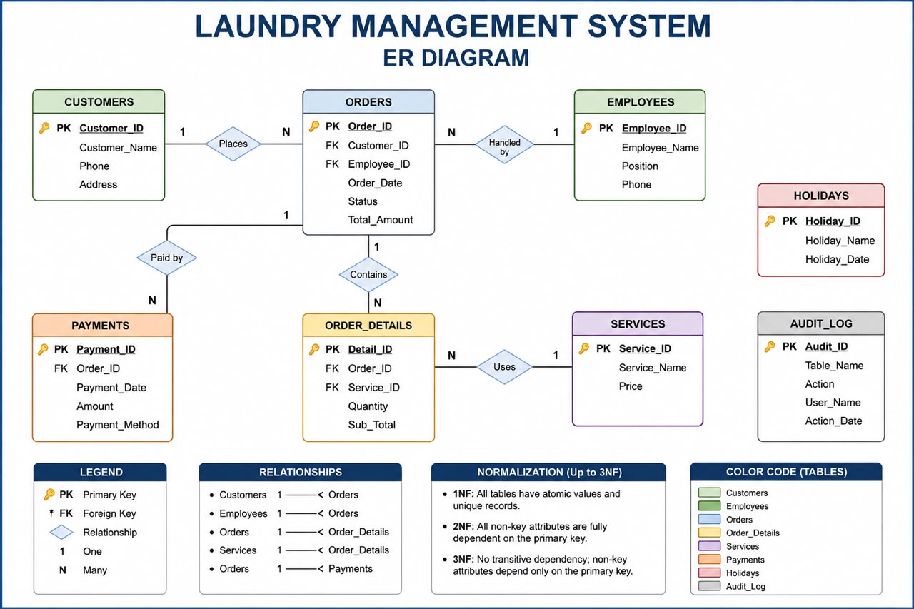
2. Design Overview
The database is designed to manage the laundry operations efficiently by maintaining clear relationships between entities.
Entities: The system includes Customers, Employees, Orders, Services, Payments, Holidays, and Audit-Log.
Normalization: All tables are normalized to 3NF to eliminate data redundancy and ensure each attribute depends solely on the primary key, providing optimal data integrity.
Relationships: The design implements a structured relational model where customers place orders, and orders contain multiple service details, ensuring accurate tracking of every transaction.

Phase IV & V: Database Creation & Table Implementation
1. Database Setup
The Oracle database was configured with the following naming convention to ensure professional tracking: ⁠31195_2025_Ahmed_Laundry_DB⁠. Proper privileges were assigned to the user to allow full control over the database objects.
2. Table Implementation
Tables were created based on the ERD design, incorporating all necessary constraints (Primary Keys, Foreign Keys, NOT NULL, UNIQUE, and CHECK constraints) to ensure high data integrity and reliability.
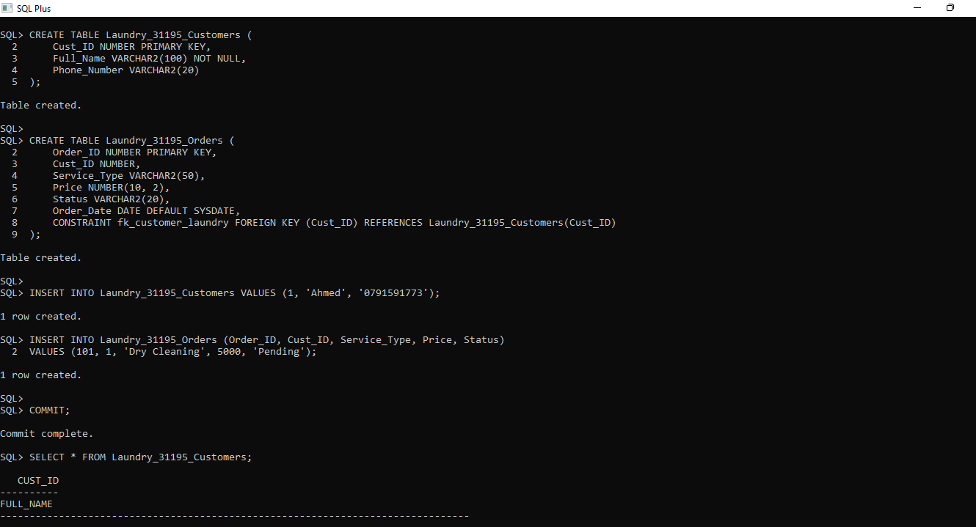

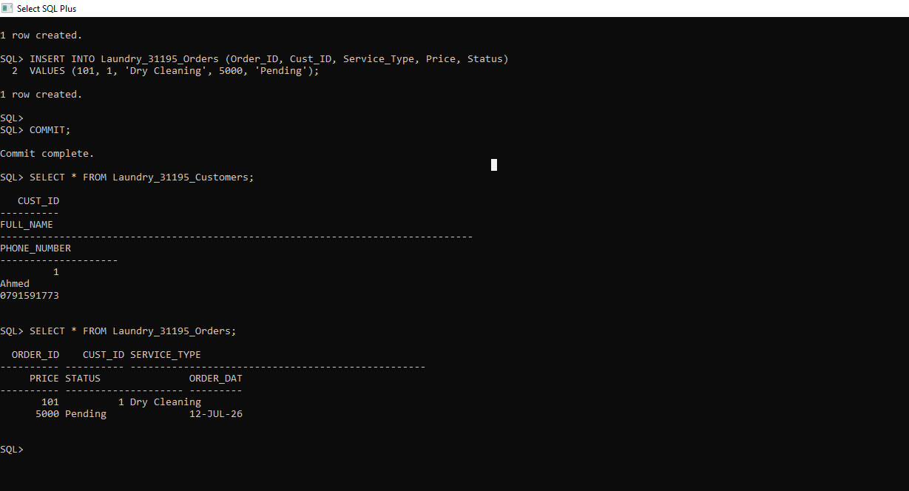

Phase VI: Advanced PL/SQL Implementation
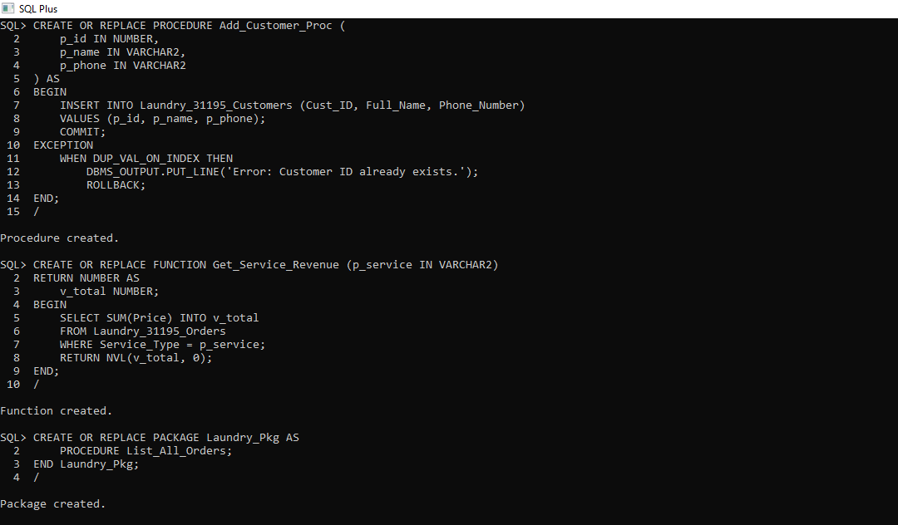

Figure: Implementation of PL/SQL Procedures, Functions, and Packages.
Description:
, Add_Customer_Proc: A stored procedure designed to insert new customer records into the ⁠Laundry_31195_Customers⁠ table, featuring exception handling to prevent duplicate ID entries.
Get_Service_Revenue: A user-defined function that calculates the total revenue generated by a specific laundry service type by aggregating data from the orders table.
Laundry_Pkg: A database package that encapsulates related procedures (such as ⁠List_All_Orders⁠), improving code modularity and maintainability within the Oracle environment.

Phase VII: Advanced Database Features (Triggers & Audit System)
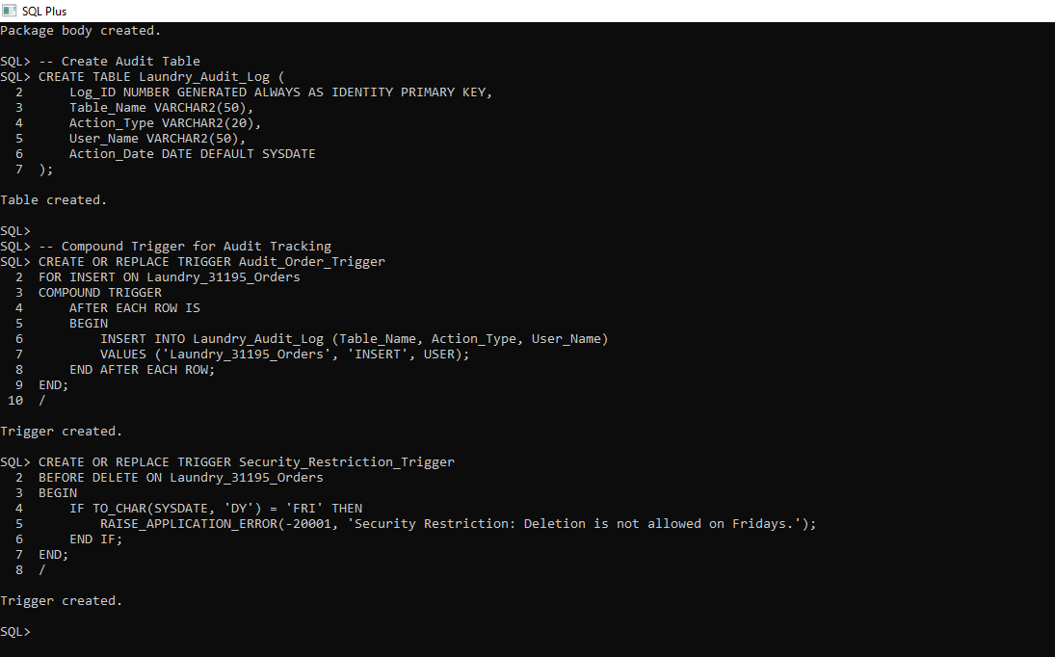
Figure: SQL implementation of Audit Log table and Security Triggers.
Description:
Audit Tracking: The ⁠Laundry_Audit_Log⁠ table was created alongside a compound trigger that automatically logs every 'INSERT' operation performed on the ⁠Laundry_31195_Orders⁠ table, capturing the table name, action type, and the user responsible.
Security Policy: The ⁠Security_Restriction_Trigger⁠ enforces a business rule that prohibits the deletion of records on Fridays, ensuring data integrity and preventing unauthorized modification during specific timeframes.

Conclusion
Conclusion
In conclusion, this project successfully demonstrated the end-to-end development of a robust and secure database management system for a laundry operation. Throughout this process, we effectively moved from conceptual modeling (ERD) to physical implementation, incorporating advanced normalization techniques to ensure data integrity. Furthermore, the integration of PL/SQL procedures, functions, and packages, combined with security-focused triggers and audit mechanisms, has resulted in a reliable and maintainable system. This project has provided a comprehensive practical understanding of relational database design and management within the Oracle environment.

